

National Investigation Agency, Kingdom of Bahrain

<Project Name>

TRAINING PLAN

Version <V-1.0>

[Date : 22/11/2020]



VERSION HISTORY

[Training Plan Template will be controlled and tracked. In the table below provide the version number, the author implementing the version, the date of the version, the name of the person approving the version, the date that particular version was approved, and a brief description of the reason for creating the revised version.]

Version  Number | Implemented  By | Revision  Date | Approved  By | Approval  Date | Description of  Change
1.0 | <Author name> | <mm/dd/yyyy> | <Project Manager name> | <mm/dd/yyyy> | <description of change>

Importance of Training
Having a trained workforce means your workers are learning new skills that can improve productivity , cut time spent in creation of your product (or service), reduce production costs, reduce mistakes, build confidence in your workforce, and create a better working environment
Benefits:
Improved employee performance – the employee who receives the necessary training is more able to perform in their job. The training will give the employee a greater understanding of their responsibilities within their role, and in turn build their confidence. This confidence will enhance their overall performance and this can only benefit the company.
Improved employee satisfaction and morale – the investment in training that a company makes shows employees that they are valued.
Addressing weaknesses – Most employees will have some weaknesses in their workplace skills. A training program allows you to strengthen those skills that each employee needs to improve.
.
Consistency – A robust training and development program ensures that employees have a consistent experience and background knowledge.
Increased productivity and adherence to quality standards – Productivity usually increases when a company implements training courses
Increased innovation in new strategies and products – Ongoing training and upskilling of the workforce can encourage creativity. New ideas can be formed as a direct result of training and development.
Reduced employee turnover – staff are more likely to feel valued if they are invested in and therefore, less likely to change employers. Training and development is seen as an additional company benefit. Recruitment costs therefore go down due to staff retention.
Enhances company reputation and profile – Having a strong and successful training strategy helps to develop your employer brand and make your company a prime consideration for graduates and mid-career changes. Training also makes a company more attractive to potential new recruits who seek to improve their skills and the opportunities associated with those new skills.
Training can be of any kind relevant to the work or responsibilities of the individual, and can be delivered by any appropriate method.

Training Methodology
1.  On-the-job learning | 2.  Mentoring schemes | 3.  In-house training | 4.  Individual study

Training program can be Best for organization Due to most important factor
- Due to Good Decision Hierarchy:
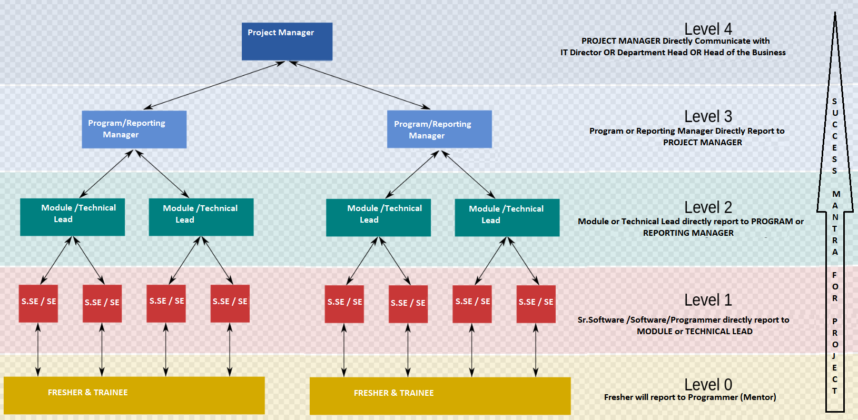

- Focus on Learning and Growth zone’s employee
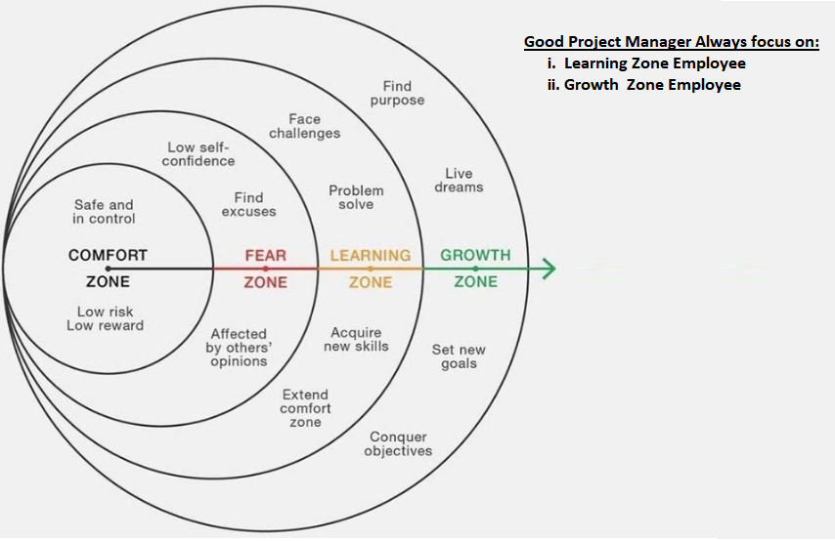

Table of Contents
<PROJECT NAME> 1
TRAINING PLAN 1
Version <1.0> 1
<dd/mm/yyyy> 1
VERSION HISTORY 2
1.0 Introduction 6
1.1 Background and Scope 6
1.2 Points of Contact 6
1.3 Document Organization 7
1.4 Security and the Privacy Act or data protection 7
2.0 Instructional Analysis 7
2.1 Needs and Skills Analysis 7
2.2 Development Approach 7
3.0 Instructional Methods 8
3.1 Training Methodology 8
3.2 Training Database 8
4.0 Training Resources 8
4.1 Course Administration 8
4.2 Schedules 9
5.0 Training Materials List 9
5.1 Purpose and Scope 9
5.2 Training Materials List 9
APPENDIX A: Training Plan Approval 12
APPENDIX B: REFERENCES 13
APPENDIX C: KEY TERMS 14

1.0 Introduction
Training is important because it represents a good opportunity for employees to grow their knowledge base and improve their job skills to become more effective in the workplace. Despite the cost of training for employees, the return on investment is immense if it is consistent.

1.1 Background and Scope

Knowledge and skills are crucial to every company nowadays. Firms are evaluated based on their physical structure and intellectual capital. The easiest way to develop and improve a firm’s intellectual capital is to conduct regular training and development programs.
Also, supporting untrained employees costs the organization more than it would if it employed well-trained individuals. Other perks of employee training and development include improvements in employee performance, boosting company reputation, and addressing weak links in the organization.

1.2 Points of Contact
All departments staff Name and their contact number
Role | Name | Contact Number
Sr.Software/ Software Engineer
Module /Technical Lead
Program Manager
Project Manager
QA Manager
Configuration Manager
Training Manager/Coordinator
Training Representatives

1.3 Document Organization
All document list come here .That is used for employee training. All document should be in shared location.

1.4 Security and the Privacy Act or data protection
Data Privacy or Information privacy is a part of the data protection area that deals with the proper handling of data with the focus on compliance with data protection regulations.So focus on some certification
- HIPPA
- CCPA
- Encryption & Decryption

2.0 Instructional Analysis

2.1 Needs and Skills Analysis
Time to time we gather the skill information from employee on the behalf of that information project manager will discuss with IT Head or Director regarding the training for some employee who has skill gap.


2.2 Development Approach
In this section we have to developed the approach for training .It has 7 type of Training approach.
7 types of online employee trainings:
1. Orientation
Orientation is the most common type of employee training. It’s a one-time event formally welcoming and introducing new hires to your company within their first week on the job. This training tends to be relevant to all company-wide roles and departments.
- Company mission, vision, and values
- Corporate culture
- Organizational structure and leadership team intro
- Mandatory new-hire paperwork
- Overview of benefit plans
- Administrative procedures (computer logins, extension, email setups, etc.)
- Key corporate policies
2. Orientation and on boarding Training
On boarding trainings ideally start on the first day of employment and may carry on throughout the first year as needed. It is prepared by department leaders with the focus of reaching departmental goals and connecting them with overall company objectives. Topics should, therefore, address employee needs and provide them with easy access to information and skills that they need to do their jobs efficiently and maximize employee engagement.
3. Technical Skill development Training
No matter what technical level your employees are at, there is always room for improvement. Technical (hard) skills include the know-how of doing things like data analysis, content writing, social media management, coding, programming, etc.
Technical skills training is a fundamental employee education component because it’s the main way your employees will know how to technically do their jobs right.
4. Soft Skill development Training
Soft skills trainings are useful for new and existing employees of all levels and are an extremely effective way to build an efficient, respectful and collaborative culture – ultimately affecting the bottom line.
Some topics to consider covering in your soft skills training include:
- Communication skills
- Presentation skills
- Problem-solving skills
- Conflict resolution
- Leadership skills
- Emotional Intelligence
- Time management
- Ethics
- Teamwork
- Adaptability
5. Product and Services Training
This type of training can also be used to educate staff on newly introduced products, services or features so they are always up to date.
6. Mandatory Training
In this section ,we trained to employee ,If you are harassed or molested by your senior .Simply you can drop a letter to your HR Department.
7. E-learning Tutorial Training
If you’re looking for a long-term solution to engage your employees, investing in their professional development beyond the online courses you offer is the way to do it.
Employees who feel their company invests in them are more engaged and happier than their counterparts. This level of engagement works two-fold for your company as both an employee retention strategy and a professional development tool.

3.0 Instructional Methods

3.1 Training Methodology
In this section ,Project manager will take an action which methodology is providing to their employee,
Training Methodology
1.  On-the-job learning | 2.  Mentoring schemes | 3.  In-house training | 4.  Individual study

3.2 Training Database
We will create a database or Excel sheet for training list already provide to the employee .On the behalf of that list we will utilize the employee in various project

4.0 Training Resources

4.1 Course Administration
[This subsection of the Training Plan describes the methods used to administer the training program, including procedures for class enrollment, student release, reporting of academic progress, course completion and certification, monitoring of the training program, training records management, and security, as required.]

Role | Years of Experience | Training Course By Phase
Project Manager  OR  Program Manager | 12+ Yrs | Phase 1 : Agile Certificate  Phase 2 : Agile Professional Certificate  Phase 3 : Scrum Master  Phase 4 : Prince v2 ITIL  Phase 5 :PMP Beginner  Phase 5 :PMP Professional
Reporting Manager | 10+ Yrs | Phase 1 : Agile Certificate  Phase 2 : Agile Professional Certificate  Phase 3 : Scrum Master  Phase 4 : Prince v2 ITIL
Technical Lead  OR  Module Lead | 9+ Yrs | Phase 1 : Agile Certificate  Phase 2 : Agile Professional Certificate  Phase 3 : Scrum Master  Phase 4 : Documentation
Sr.Software/ Software Engineer | 5+ Yrs | Phase 1 : Agile Certificate  Phase 2 : Software Quality and Reusability  Phase 3 : Code Methodology  Phase 4 : Update Skill [Eg: C++,C#,Asp.net ,MVC,.net Core]  Phase 5 : Team Handling and Team Cooperation
Trainee And Fresher | 0-1 Yrs | Phase 1 : Code Methodology  Phase 2 : Beginner Skill [Eg: C++,C#,Asp.net ,MVC,.net Core]  Phase 3 : Debugging and Tracing Methodology  Phase 4 : Give small task under the supervision of Mentor  Phase 5 : Update Skill [Eg:- Mobile,Window,Web etc]  Phase 6 : Focus on Neat and clean and Reusable The Code

4.2 Schedules
Schedule will decide as per Hierarchy.
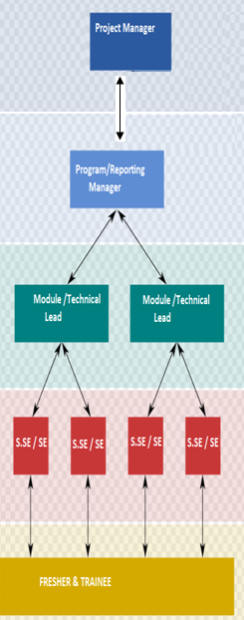

5.0 Training Materials List

5.1 Purpose and Scope
The purpose of this document is to assist the project manager and project team in managing the training materials produced by the project as part of the <Project Release Name>. Training materials can include: seminars, presentations, workbooks, self-study tutorials, etc., associated with a software version release.

5.2 Training Materials List
[Populate the table below with the applicable information when the training material is being developed or delivered. Add or remove any columns as necessary.]
Explanation of the table fields:
- Document Name: Provide the name of the document
- Version Number: Provide the version of the document being distributed (this information may already be in the Document Name)
- Document Format: Provide the format the document is saved or delivered as. This could be a:
  - Word Document
  - PowerPoint Presentation
  - Excel Sheet
  - Etc.
- Date Delivered: Provide the date the training was provided or the documents were distributed.
- Intended Audience: Identify the target group that the document was created for. This could include:
  - Executive management
  - General Users
  - Power or Super Users
  - Technical Support Staff
- Storage Location: Identify the location the master documents are stored. For electronic documents, provide the network location. For printed documents, provide a physical location.

Software Training Materials List for <Project or Release Name>
Document Name | Version Number | Document Format | Date Delivered | Intended Audience | Storage Location

APPENDIX A: Training Plan Approval
The undersigned acknowledge that they have reviewed the <Project Name> Training Plan and agree with the information presented within this document. Changes to this Training Plan will be coordinated with, and approved by, the undersigned, or their designated representatives.

Signature: |  | Date:
Print Name:
Title:
Role: | Project Manager / Program Manager

APPENDIX B: REFERENCES
The following table summarizes the documents referenced in this document.
Document Name | Description | Location
<Document Name and Version Number> | <Document description> | <URL or file path to where document is located>
APPENDIX C: KEY TERMS
The following table provides definitions and explanations for terms and acronyms relevant to the content presented within this document.
Short Term | Definition
HIPPA & CCPA | Health Insurance Portability and Accountability Act & California Consumer Privacy Act

